Experiment No: 11
Experiment Name: Study of constructing digital logic circuit using semiconductor devices
Objectives:
- To implement digital logic circuits (OR & NOR) using any of the semiconductor devices
- To verify logic operation using LED ON/OFF indication
Theory:
Digital logic gates are fundamental components of digital electronics that operate on binary inputs (0 and 1). In this experiment, semiconductor devices such as diodes and transistors are used to construct logic gates. Inputs are applied manually using +5V (logic HIGH) and ground (logic LOW), while the output is indicated using an LED, where ON represents logic 1 and OFF represents logic 0
OR Gate:
An OR gate produces a HIGH output when at least one of its inputs is HIGH. In the implemented circuit, transistors act as switches that allow current to flow when any input is HIGH. As a result, the LED turns ON if either input A or B (or both) is HIGH. If both inputs are LOW, no current flows through the circuit and the LED remains OFF
NOR Gate:
A NOR gate is the complement of the OR gate and produces a HIGH output only when all inputs are LOW. In this circuit, the OR gate output is passed through a transistor-based inverter. When any input is HIGH, the transistor conducts and pulls the output LOW, turning the LED OFF. When both inputs are LOW, the transistor remains OFF, resulting in a HIGH output and the LED turning ON
Required Apparatus:
- BJT (BC547, 2 piece)
- Resistors (270 kΩ: 3 pieces & 1 kΩ: 2 pieces)
- LED (Red)
- DC Power supply (0-15V)
- Project board
- Multimeter
- Connecting wires

Circuit Diagrams:
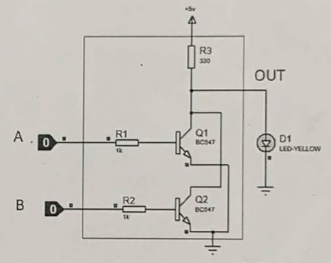
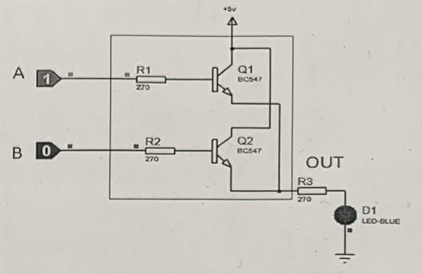
Figure (a): OR Gate
Figure (b): NOR Gate

Experimental Results:
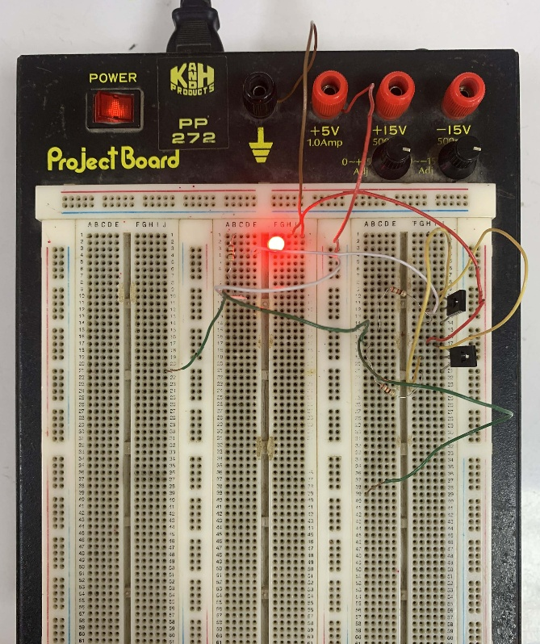
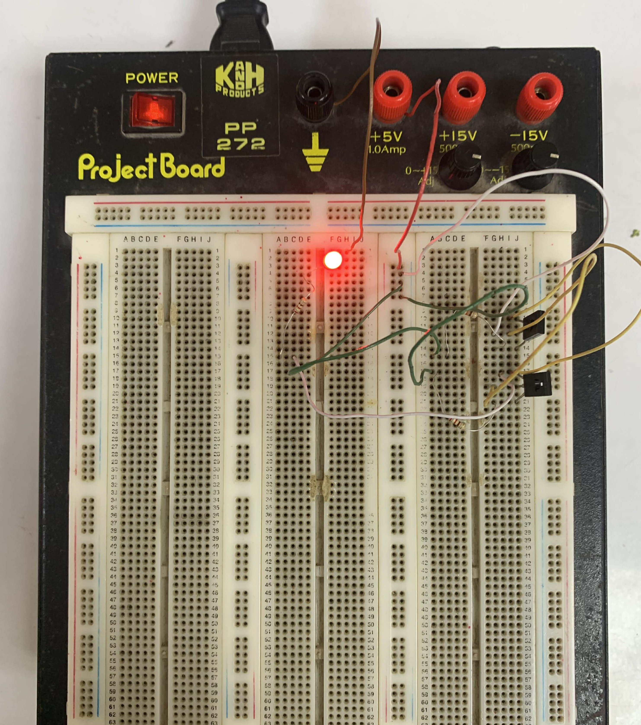

Figure (a): OR Gate
Figure (b): NOR Gate
Discussion and Conclusion:
In this Open-Ended Lab, the OR and NOR gates were successfully implemented using transistors, diodes and resistors. The LED indications clearly verified the logic operation without waveform tools demonstrating how digital logic works in real hardware systems
Precautions:
- Ensured correct transistor pin configuration (Emitter, Base, Collector)
- Avoided loose connections and maintained correct +5V and Ground connections

